FAQs
What are the Age/Birthday requirements?
Your child’s age group for a particular season is determined by their age on April 30th of the following year. For example, your child is in the Shetland/5U age group if they will be 5 years old on the next April 30th. They would play in the Clydesdale/6U age group if they turn 6 prior to the next April 30th.
For the Fall 2023/Spring 2024 seasons the following age chart applies:
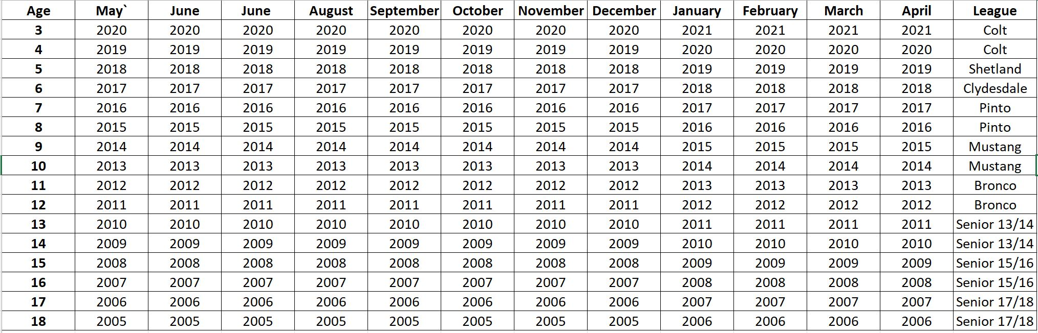

My son/daughter has never played or has little experience, can he/she play down in a younger age group?
Braves Country Baseball and ABA rules do not allow for playing down an age group. Because ABA is a Recreational Baseball Park, there will always be kids that are new to baseball. We welcome players of all skill levels and experience.
When does the season start/when does registration open?
Fall registration signup start in late June and the Fall Seasons begin in August and is finished by the early November. Spring registration signup starts in November and begins in February and finishes by early May.
What is the weekly schedule/time commitment?
Each team is scheduled for one practice/game during the week and one practice/game on Saturday. Coaches might schedule additional practices when field time permits, or they might schedule a practice at another location. Rainouts will be scheduled as time permits in the schedule so you may have an additional event during the week.
The exact schedule cannot be set until the number of teams, coaching staff and other variables are determined. Once the schedule is set it is distributed by TeamSnap and located on our website, AcworthBaseball.org.
Where are games and practices held?
For ages 3U through 12U, all games are played at Kenworth Park (3900 South Main Street).
For 13U and up (Senior league) practice and play at our two senior fields Newberry Park and Durr Field. They participate in the Cobb County Interleague and play at other participating parks.
What does the park provide with my registration fees?
Your registration fee includes a hat, jersey, pants, belt and socks.
What type of equipment does my player need?
Your player should have the following equipment for each season: Required: Baseball Glove, Baseball Bat (bat requirements located below), Cleats, and a Helmet Optional: bat bag, batting gloves.
What bat does my player need?
Bat Rules: Any bat used at ABA must have an easily identifiable stamp/logo showing that it is a USA or USSSA 1.15 BPF certified bat. Wooden bats are also permissible.
What if I want my player to play with a friend or have a specific coach?
*Colt (3U/4U) is the only age group that we allow special requests to play with a friend and to request a specific coach. *Please note that for Colt league requests, we will make every attempt to assign your player with the requested friend and/or specifically requested coach but that it is not guaranteed. At times the request for the same coaches exceeds the number of available spots. Please contact the Colt director at colt@acworthbaseball.org for special requests.
What if I want my player to play up in the next age group?
If you are interested in your child playing in the older age group please send a request in writing to your current League Director* before skills assessment. Determination is based on skill level during skill evaluation (must be assessed as being in the top 10% of the league they are playing in) and available spots. Your player must attend both their current age group as well as the league they are trying to play up to on the day of the assessments. *You can locate your league director on the Board of Directors tab on the home page.
Do I need to have my player at the Skills Assessment?
All players will need to attend the skills assessment. If your player is trying to play up, they must be assessed in their current age group as well as the age group they are trying to play up to. All dates and times will be posted on the website and on Facebook as the dates approach. Rain out dates are typically the following weekend. Colt league players do not participate in skills assessment. There are no make-up dates for skills assessment.
What happens after the Skills Assessment?
After each player is assessed, they will be drafted to a team within one week of the skills assessment. Your player's coach will contact you before the first practice.
How can I get notified on Practices, Games, and Field Status?
For ages 3U through 12U, we utilize an app called TeamSnap. We send all communications through this app. Field closures are determined by the City of Acworth’s Parks and Rec team. As soon as we receive updates, information is sent through TeamSnap and posted to our social media accounts.
How can I become a coach?
Please reach out to your league director. League director emails are listed on the Board of Directors tab on the home page at AcworthBaseball.org.
I would like to join the Board of Directors, when are elections?
Acworth Baseball Board of Directors: Elections are held the 3rd week of April. If you are interested in being a board member please email secretary@acworthbaseball.org . There are no paid board member positions.

